# Design

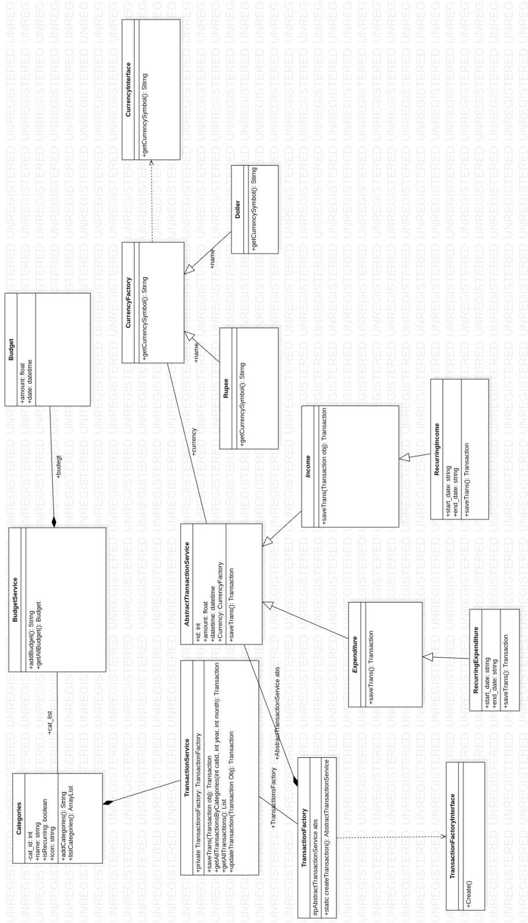

*Figure 1 Overall Backend Class Diagram of the Application*

# Implementations

##### A couple of places with tight coupling were discovered while evaluating the initial class diagram for the implementation. The following design patterns were used to maintain a loose coupling, high cohesion and improve the code readability:

#### Factory pattern

.

##### To get the transaction type object such as Income or expenses or recurring expense or recurring income. **TransactionFactory** class creates the necessary objects.

##### To generate the currency symbol such as rupee and dollar. **CurrencyFactory** class was used to create the relevant currency symbol.

#### Bridge pattern

* + **AbstractTransactionService** class and **TransactionController** have an attribute “Currency” that can be used to generate the relevant symbol based on the parameters.

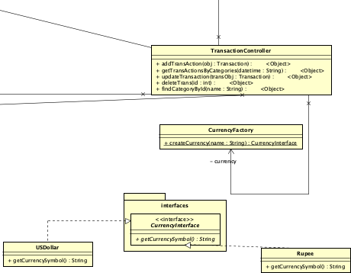

*Figure 2 Example use of Bridge and Factory Pattern in the Application*

#### Abstract pattern

##### **AbstractTransactionService** class was implemented to abstract the two transaction types found throughout the system namely Income and Expenses.

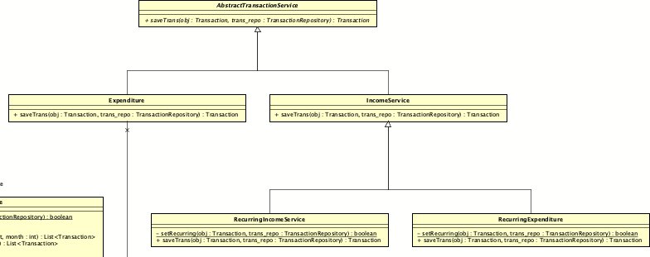

*Figure 3 Example use of Abstract Pattern in the Application*

# Testing

##### Two types of testing were performed to ensure that the software worked as expected and that the new feature did not interfere with existing functionalities.

##### **API Testing** – postman client was used to test each endpoint after adding a new feature. Postman collection is included in the attached achieve file.

##### **Manual Functional Testing** – while leveraging deployed remote application and end- to-end manually regression test was conducted before submission.

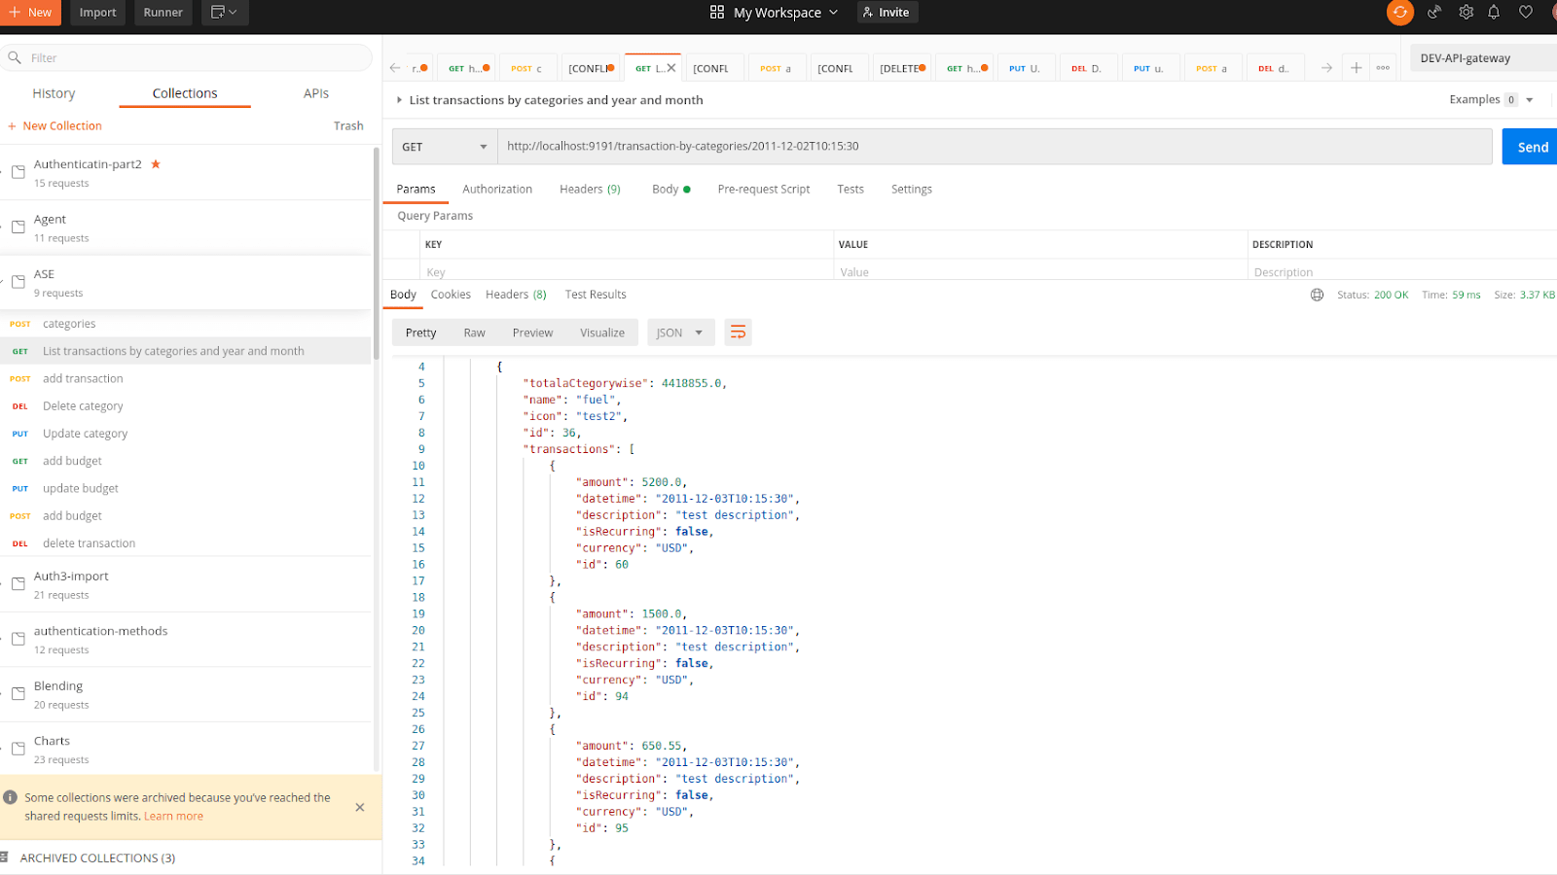

*Figure 4 Screenshot of the API tests*

# Contributions

##### The responsibilities were divided among the team members as follow.

#### Project Manager –

##### Murshid oversaw the project's leadership and management for the first four meetings.

##### Azeem oversaw the rest of the meetings and the team's leadership.

#### Designer –

* + - **Use case, Class Diagram and ERD:** Murshid and Azeem
    - **Design Pattern and Programming Logics:** Murshid and Azeem

#### Developer –

* + - **Frontend Development:** Murshid

#### Backend Development: Azeem

* + - **CI/CD:** Murshid